**EXPERIMENT-11**

**NAME:** SHAIKH MUBASHIRA TUFEL AHMED

**ROLL NO:** 612055 **COURSE:** ADVANCE DEVOPS(ITL504)

**BRANCH:** T.E. INFORMATION TECHNOLOGY (SEM 5)

**Q1) What is AWS Elastic Beanstalk?**

* Amazon Elastic Beanstalk is a web infrastructure management service. It handles deployment and scaling for web applications and services.
* Elastic Beanstalk can automatically manage setup, configuration, scaling and provisioning for other AWS services.
* AWS services that can be automatically manage include Amazon EC2 (Elastic Compute Cloud), Amazon S3 (Simple Storage Service), AWS RDS (Relational Database Service), Amazon DynamoDB, and Amazon SimpleDB.

**Q2) Who should use AWS Elastic Beanstalk?**

**🡺** Those who want to deploy and manage their applications within minutes in the AWS Cloud. You don’t need experience with cloud computing to get started. AWS Elastic Beanstalk supports Java, .NET, PHP, Node.js, Python, Ruby, Go, and Docker web applications.

**Q3) Deploy a web Application[ any language] using AWs Elastic beanstalk.**

**Step 1: AWS Management Console Dashboard.**

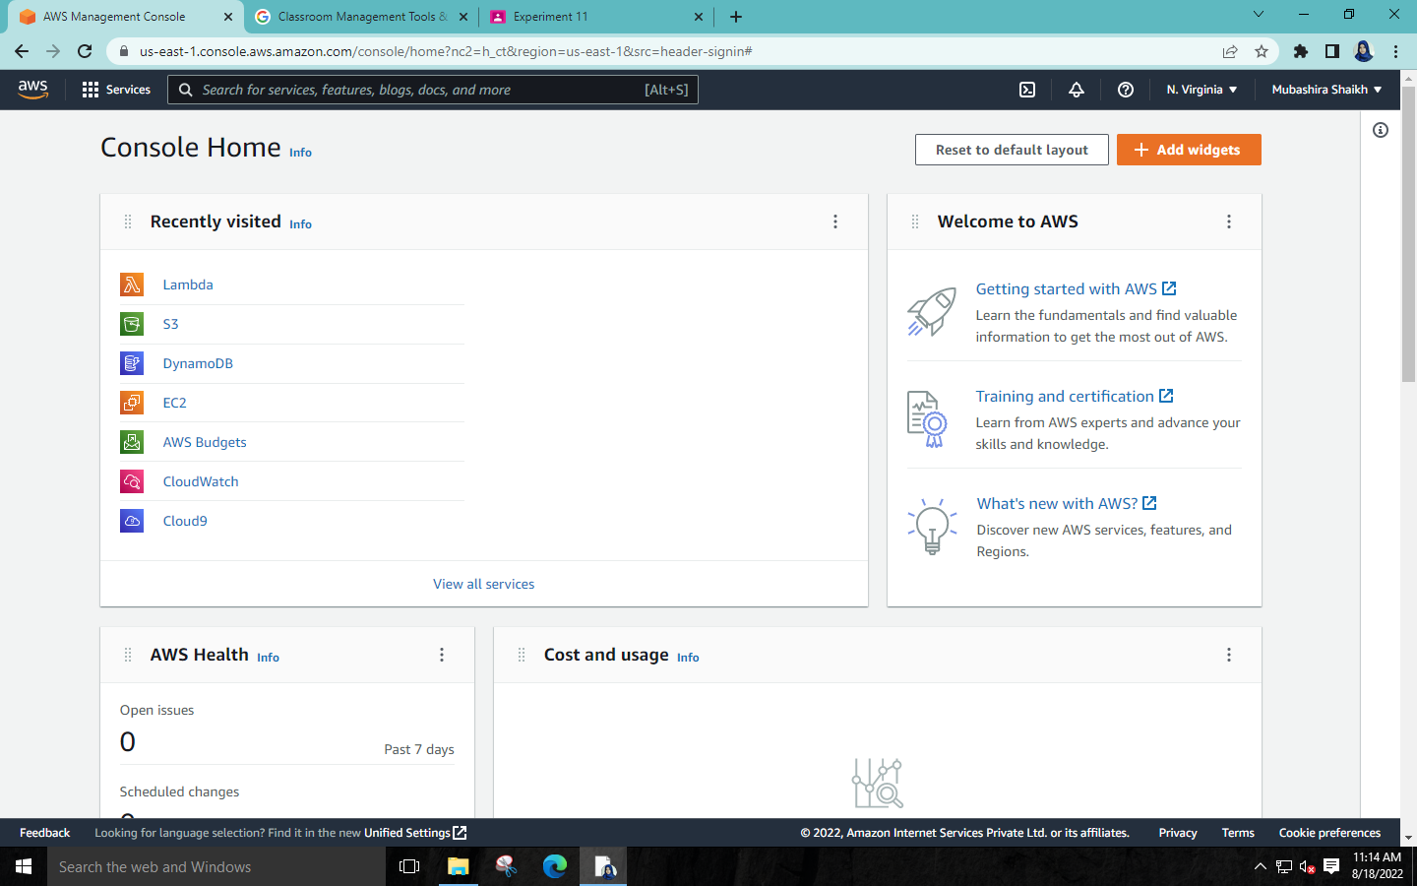

**Step 2: Search for “Elastic Beanstalk” and select it.**

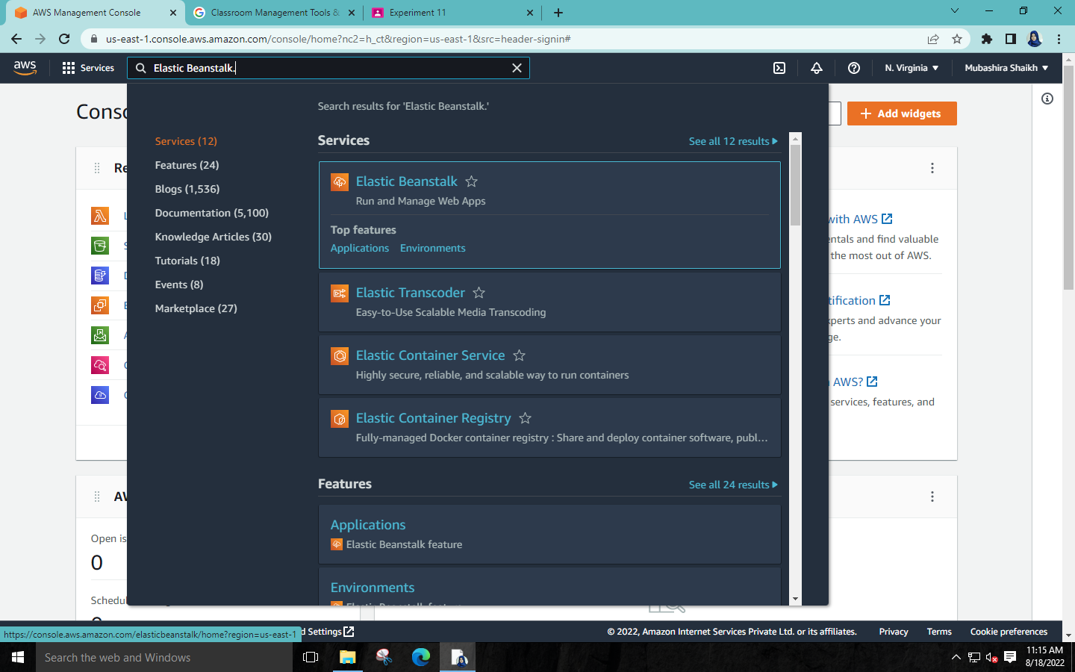

**Step 3: Click on Create Application.**

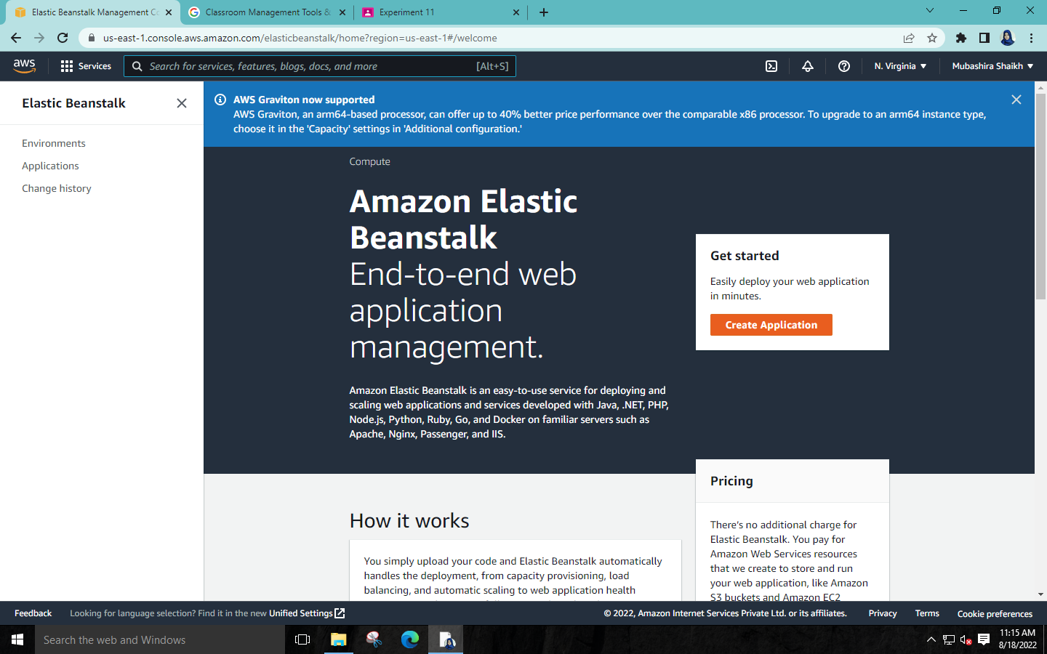

**Step 4: Give a name to Application.**

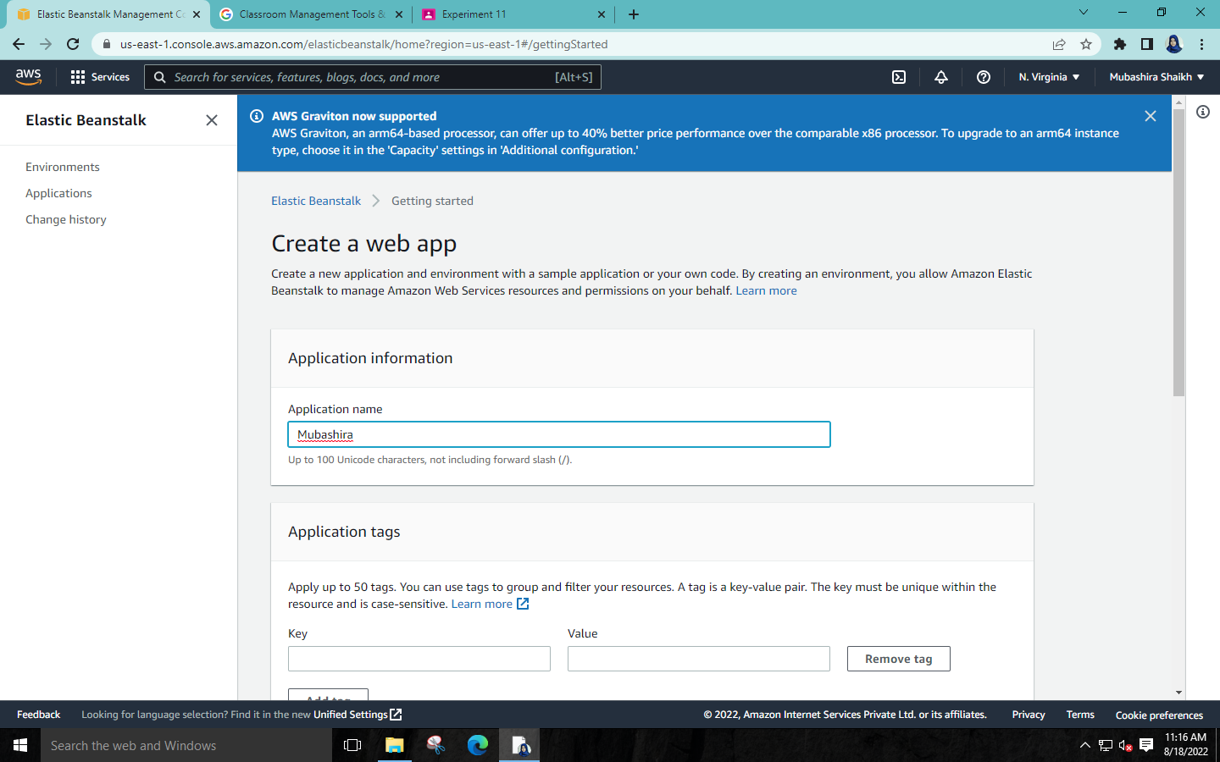

**Step 5: We can select any platform so I have selected (Python) and we**

**have to select sample code and click on Create Application.**

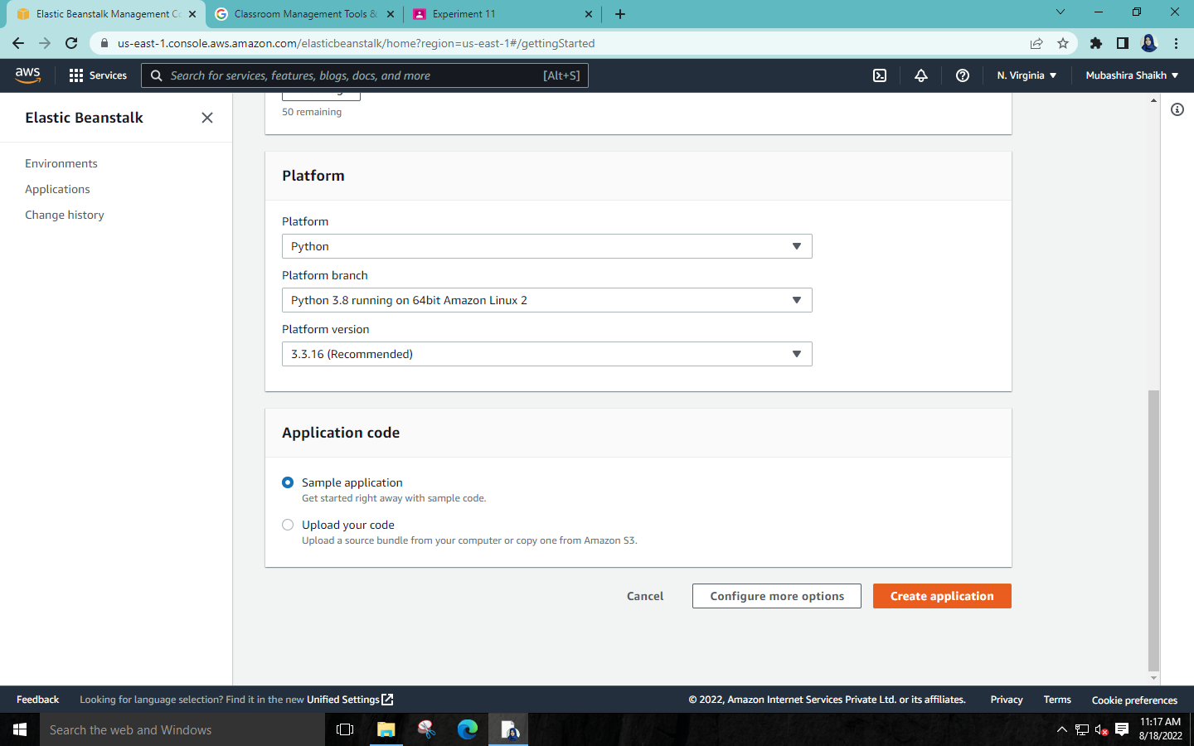

**\* Now its Creating the Application and it will take approx 5 to 10**

**mins to process.**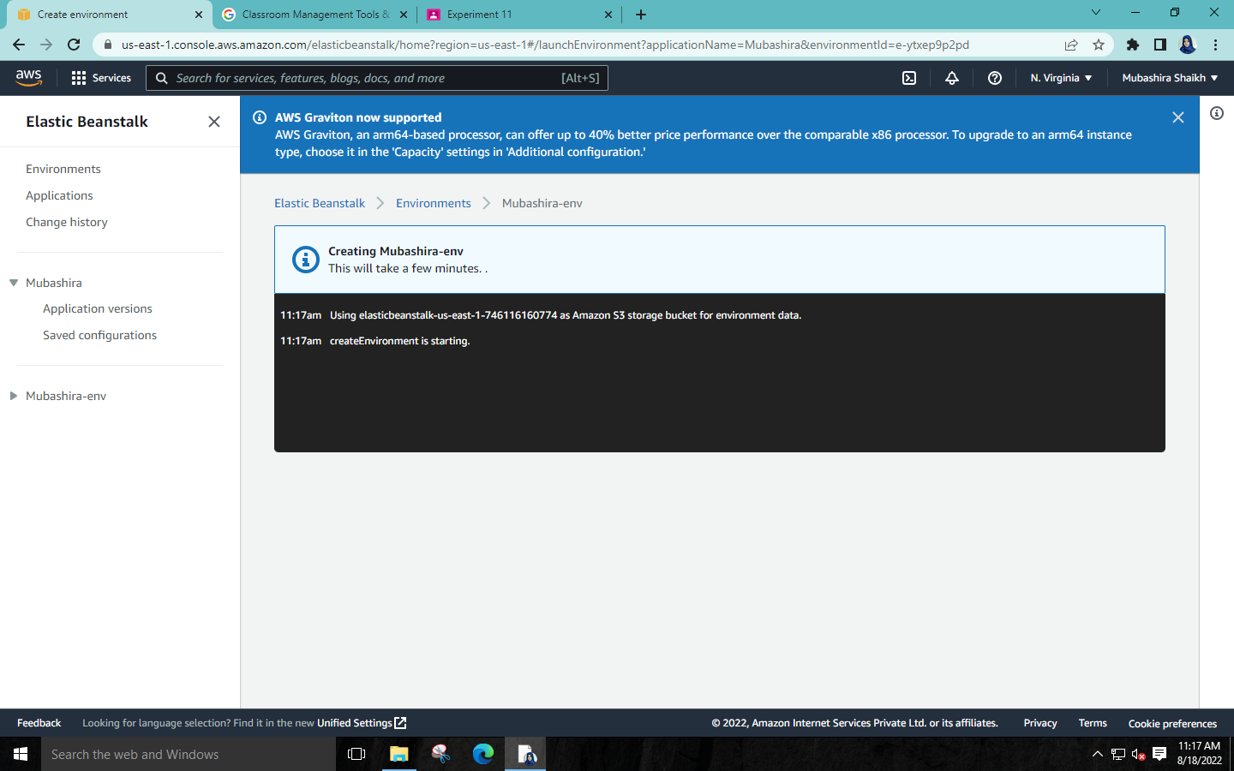 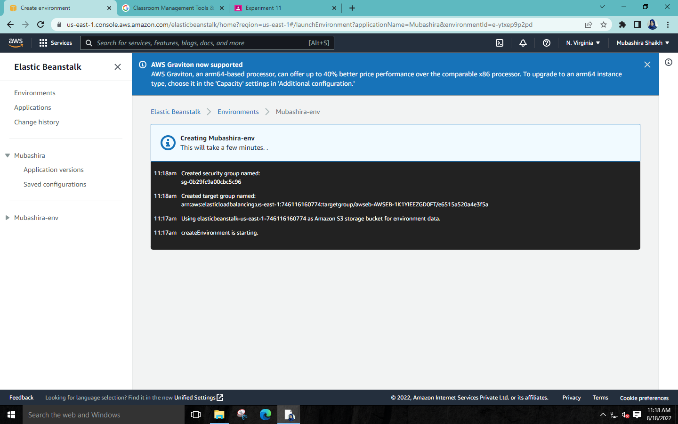

**\* The Application has been created (Python)**

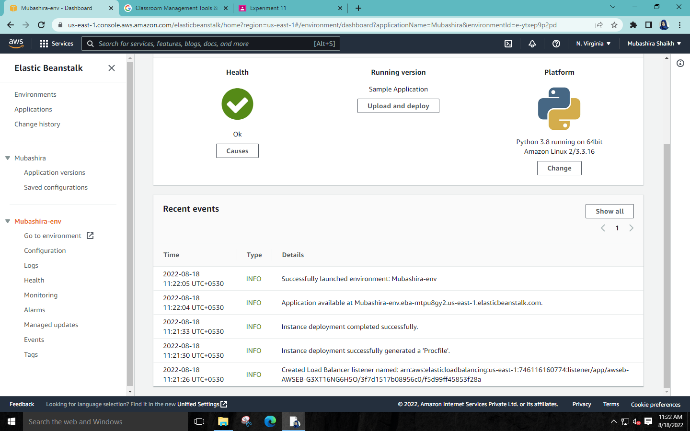

**Step 6: Click on the URL given.** 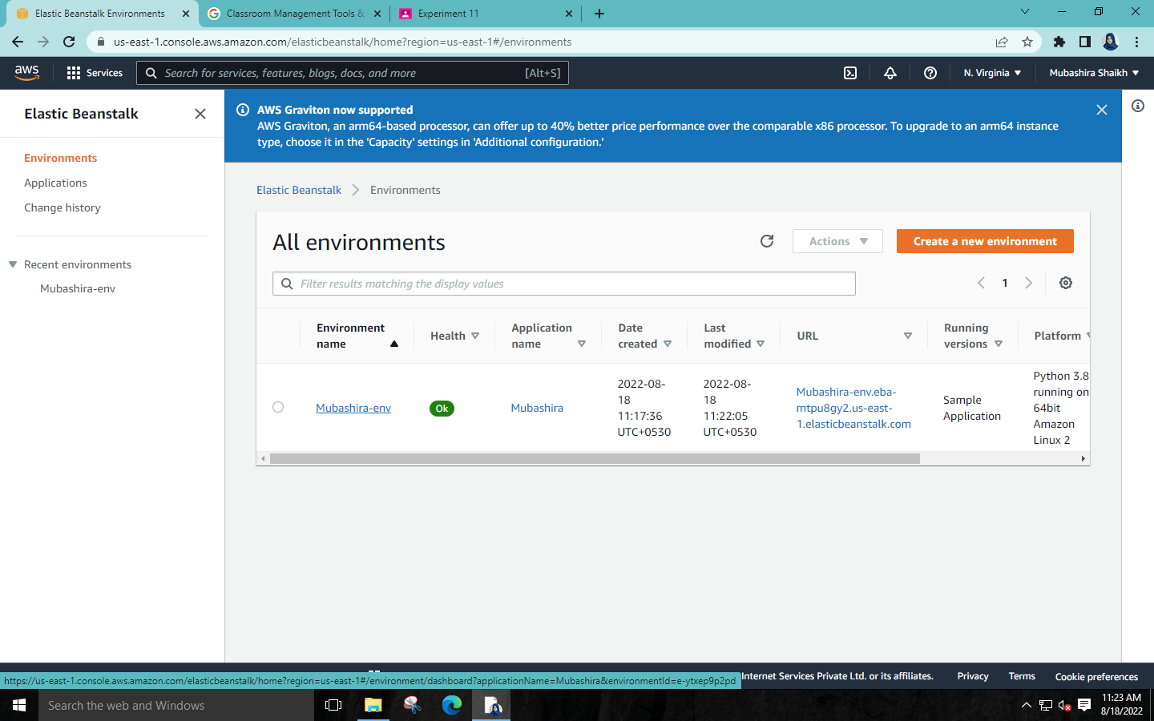

**\*** **Congratulations your Python Application has been created.**



**Step 7: Now go to EC2 and click on instances.** 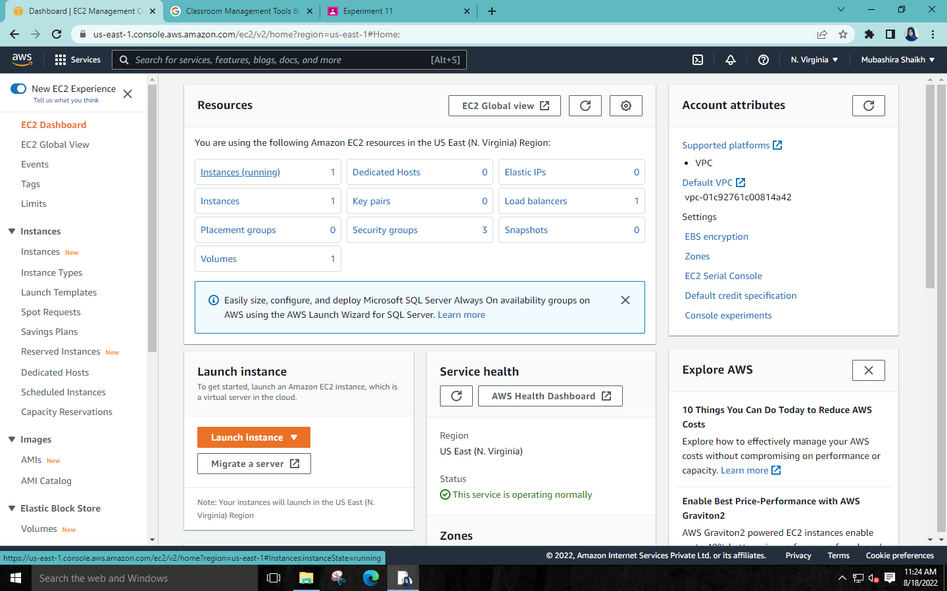

**\*This is the influence of Elastic Beanstalk on EC2 and now the instance is running.**

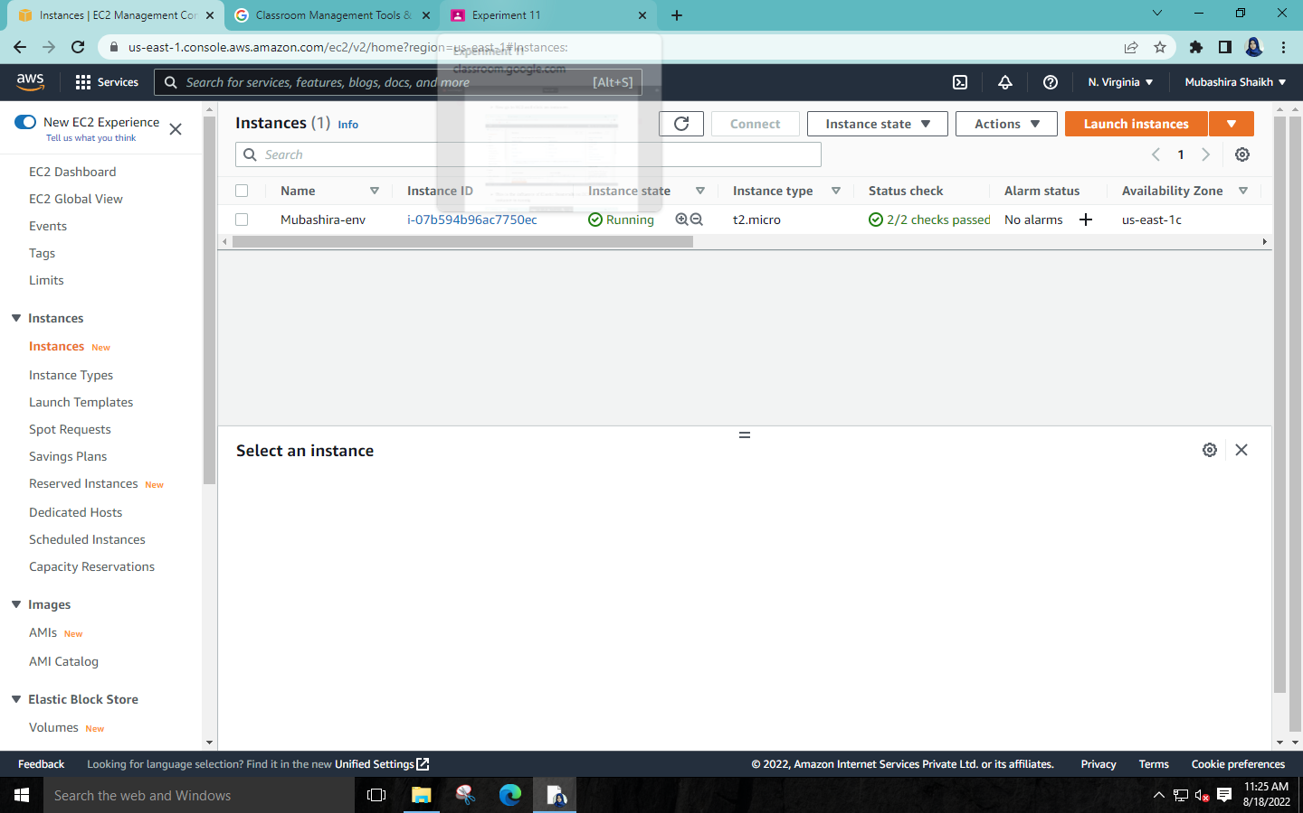

**\*We can see all the details of the instance.** 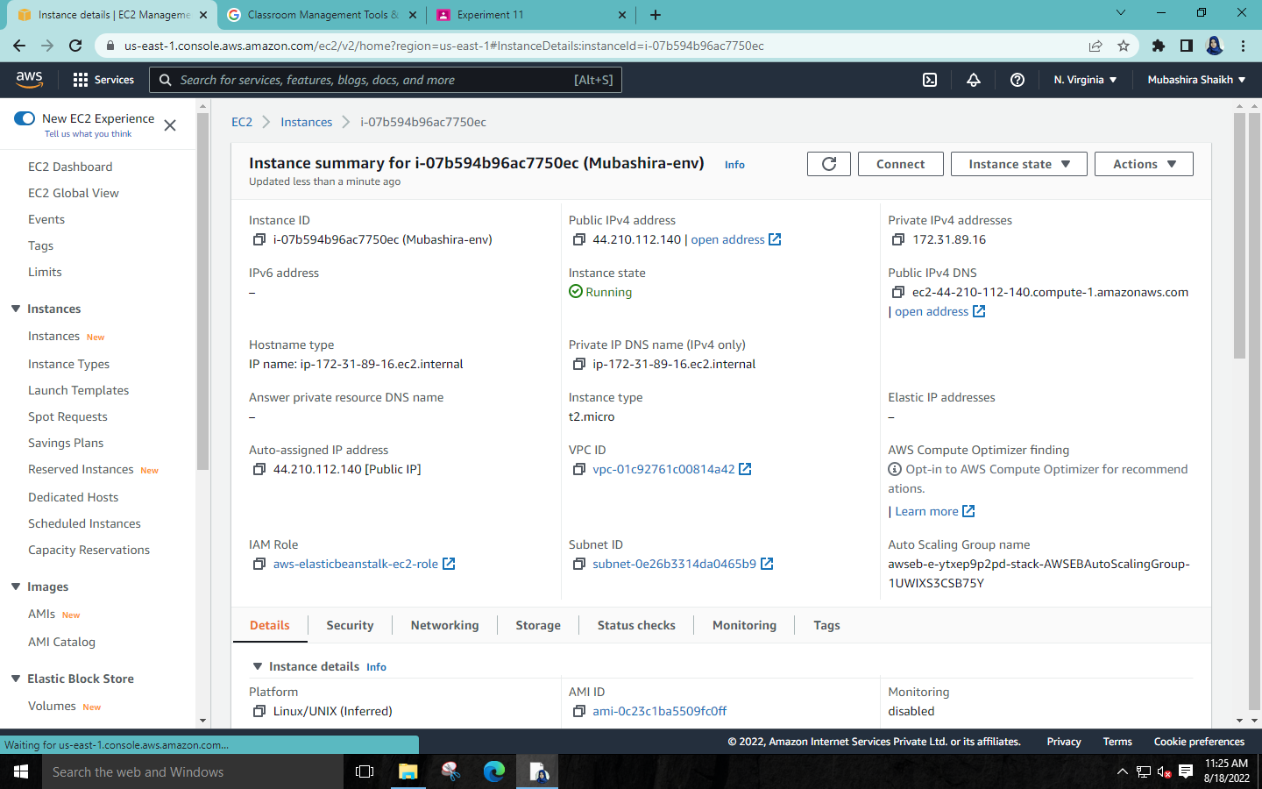 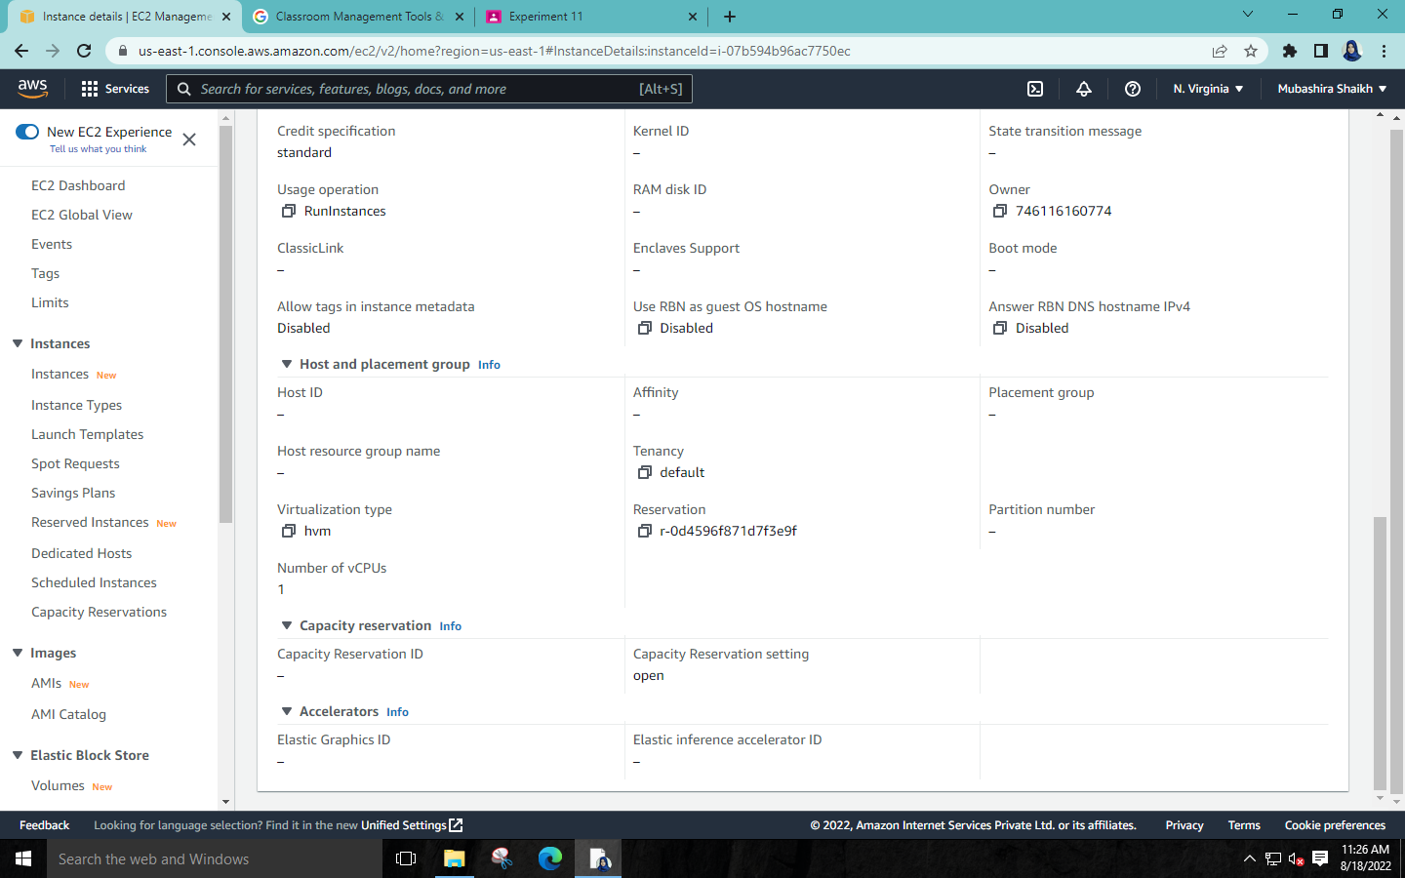

**Step 8: Now terminate the instance.**

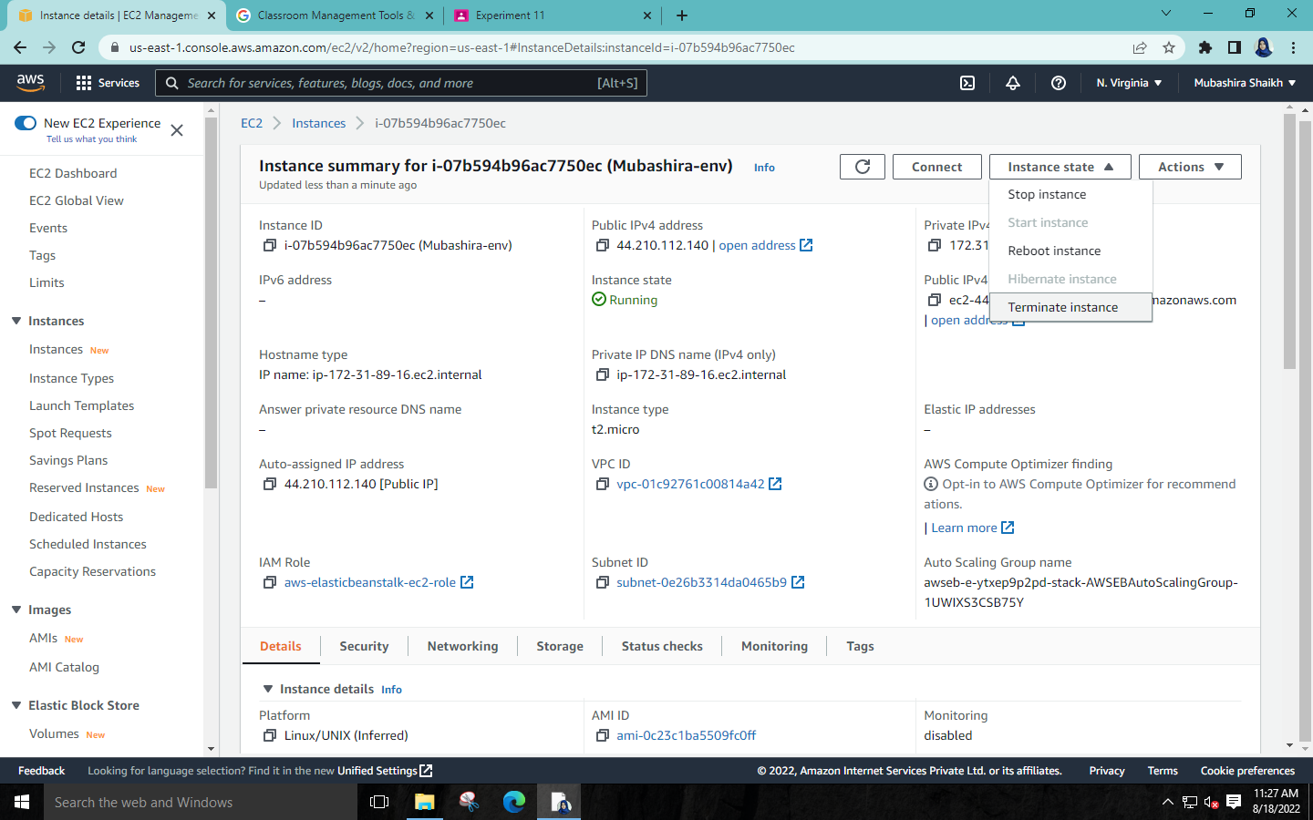 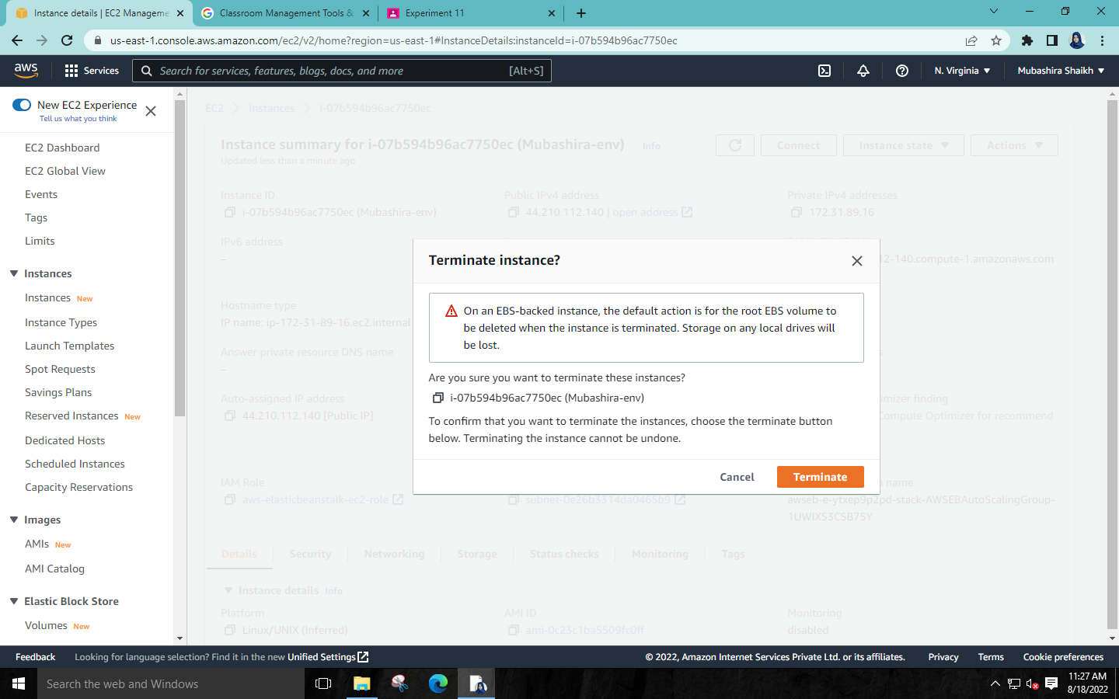

**\*The instance has been terminated.**

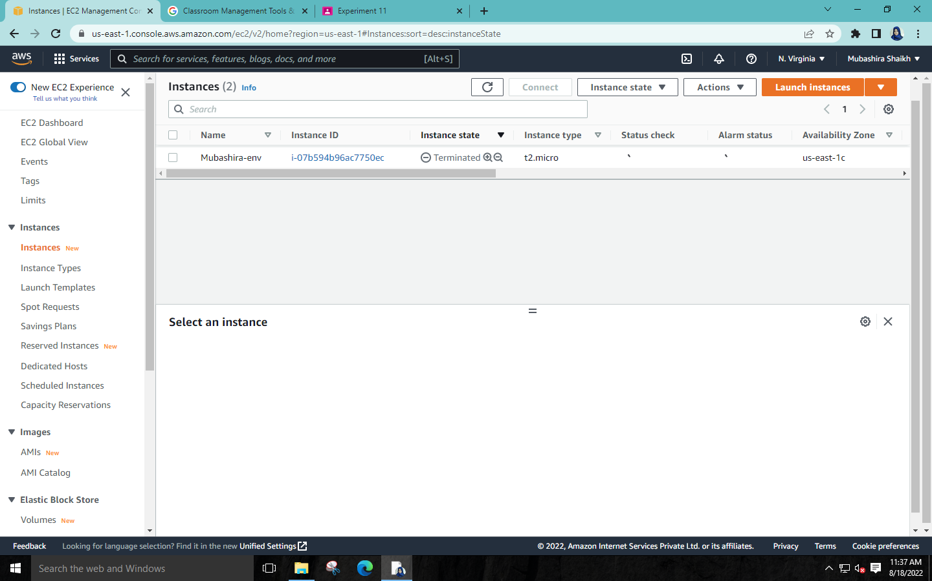

**Step 9: Now terminate the Environment.**

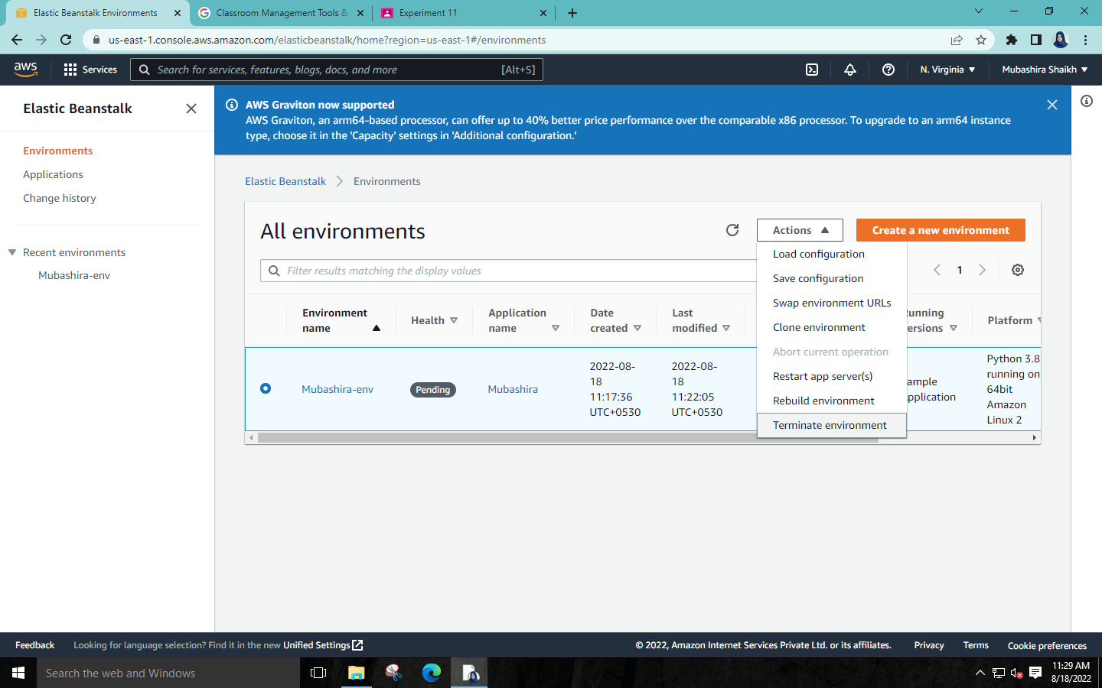

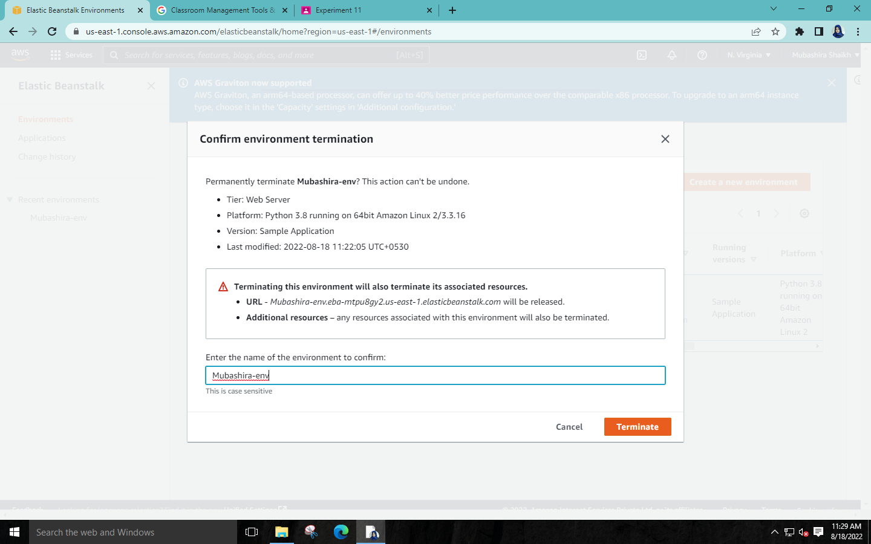

**Step 10: Now delete the Application.**

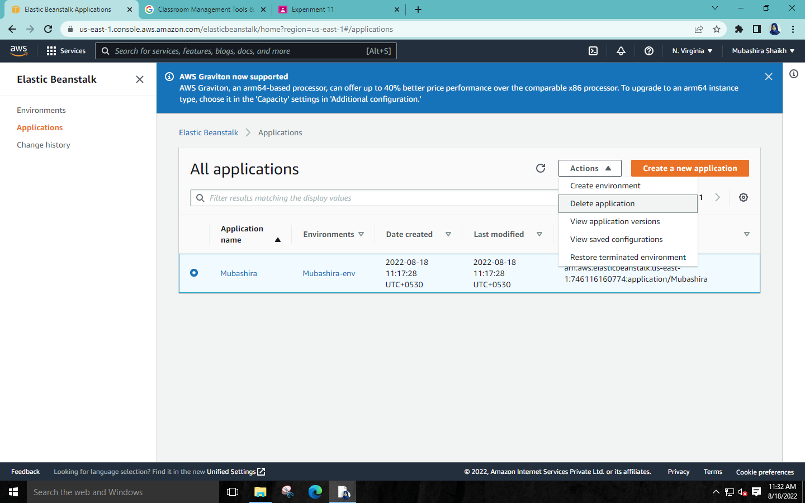

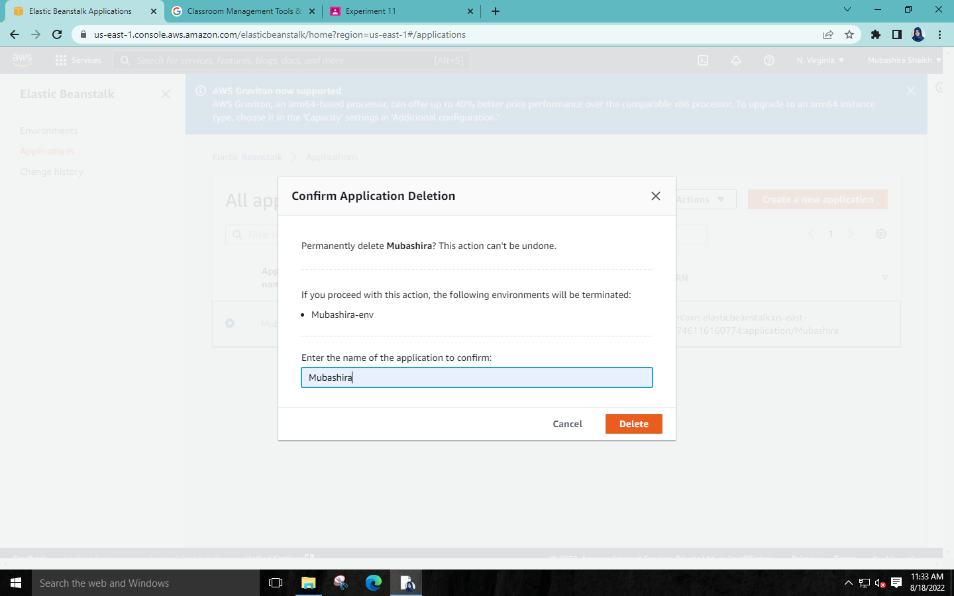

**\*The Application is deleted.**

